**Assignment 5: Create a public bucket in AWS. Upload a file and give necessary permissions to access the file.**

Creating public bucket

1. Go to **Search** and search S3.
2. Click on **Create Bucket.**

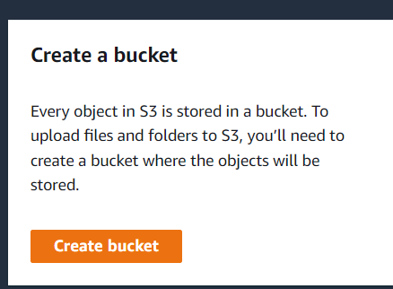

1. Give a unique Bucket Name.
2. 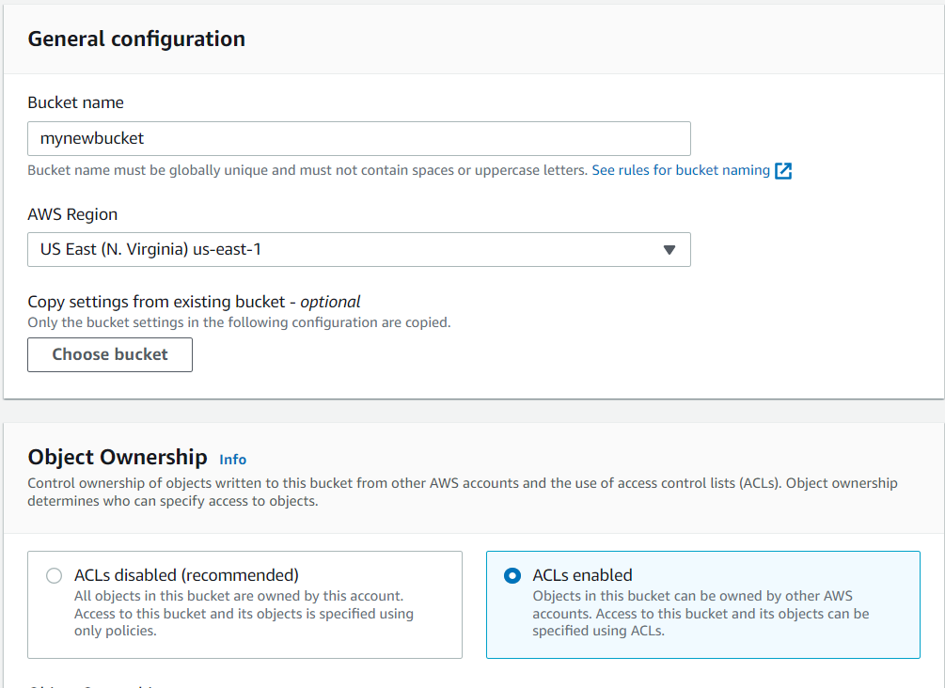Check **ACL Enabled**.
3. UnCheck **Block all public access.**

1. 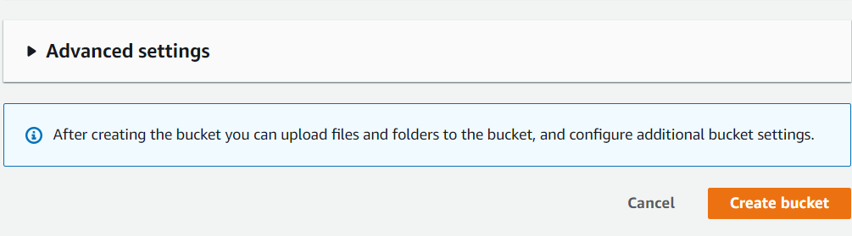Click **Create Bucket.**
2. Click on Bucket name to enter into our bucket.
3. 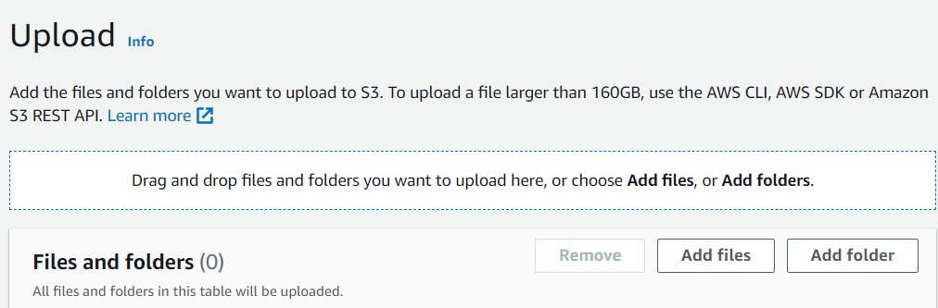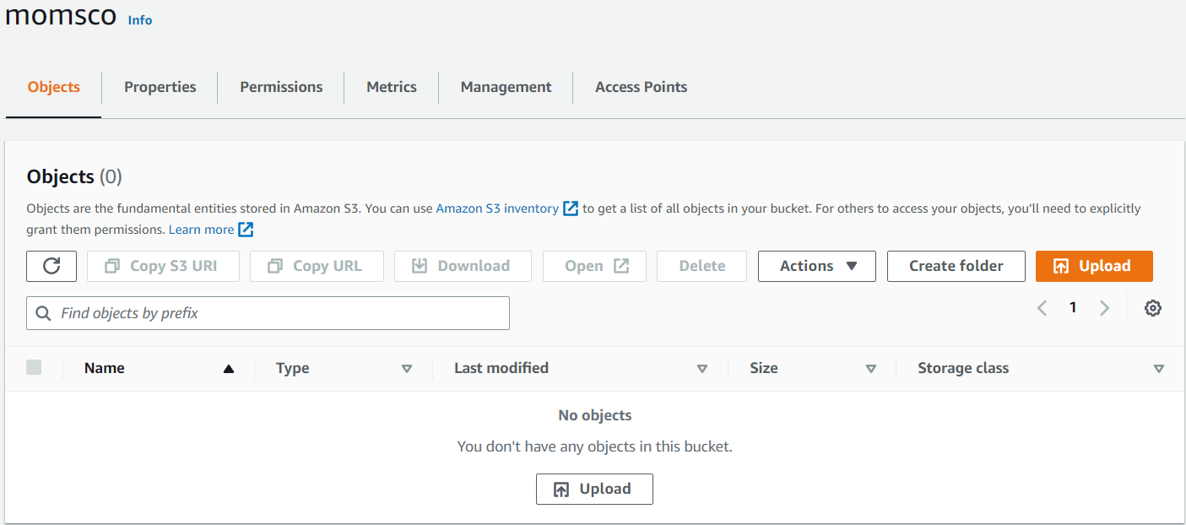Choose **upload** and **‘add files’** or **‘add folders’** upload the required files or folders.



1. 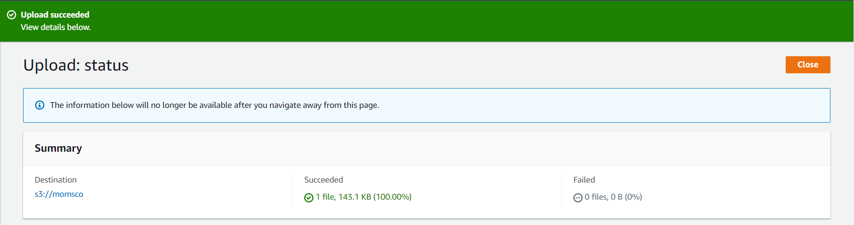Click **Upload**, after upload completion click **Close**.

Public bucket access control

1. Click on **document.**
2. Go to **permissions.**
3. Click **Edit in ACL**.

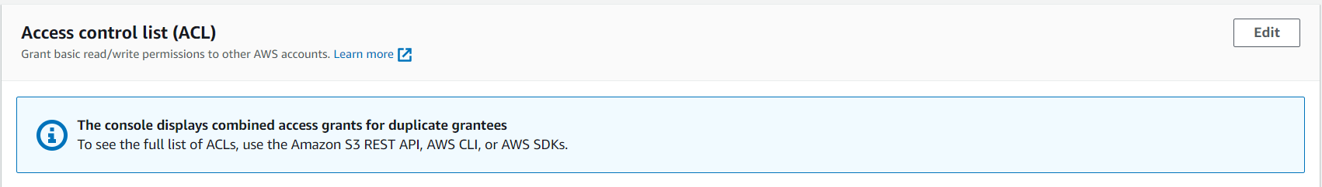

1. 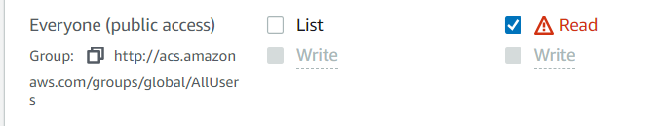Check the boxes for “Everyone public access read”.
2. Check “ I understand”.
3. 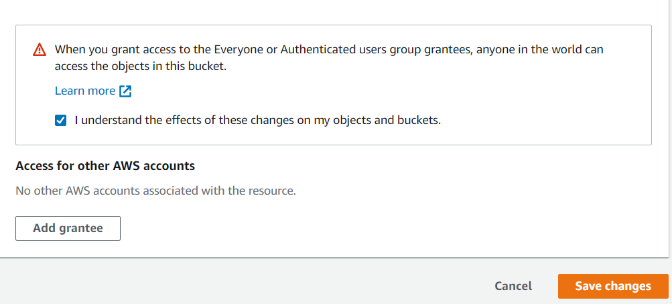Save changes.
4. Refresh object url and use it.